Question : 1
Given an array of daily step counts from your fitness app for one week (e.g., [4500, 7000, 5000, 8000, 4000, 9000, 6000]), calculate the variance by hand using the variance formula and show each calculation step :

Steps : [4500, 7000, 5000, 8000, 4000, 9000, 6000]

Mean = ∑x / n

$$Mean=\frac{4500+7000+5000+8000+4000+9000+6000}{7}$$
Mean = 43500​​ / 7 6214.29

Steps (x) | x − Mean | (x − Mean)²
4500 | -1714.29 | 2,938,796
7000 | 785.71 | 617,347
5000 | -1214.29 | 1,474,510
8000 | 1785.71 | 3,188,776
4000 | -2214.29 | 4,903,082
9000 | 2785.71 | 7,760,204
6000 | -214.29 | 45,918

Sum of squared deviations : 20,928,571.43

population variance : Variance = Σ(x − x̄)² / n
x = Each value
x̄ = Mean (Average)
n = Number of values
Σ = Sum of all values

$$Variance=\frac{20,928,571.43}{7}$$
Variance ≈ 2,989,795.92​ steps²

Question : 2
Write a Python function called calculate_standard_deviation(scores) that takes a list of exam scores and returns the standard deviation rounded to two decimal places :

import statistics
def calculate_standard_deviation(scores):
return round(statistics.pstdev(scores), 2)
scores =[80,75,90,85,70]
result =calculate_standard_deviation(scores)
print(f"Standard Deviation:{result}")

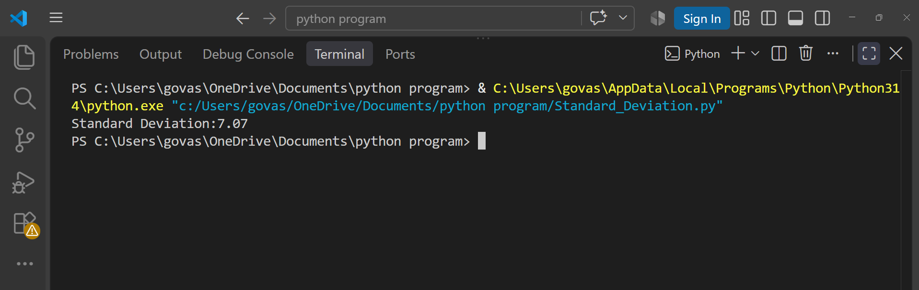
Question : 3
Imagine two friends track their daily spending on Zomato over 5 days. Friend A spends [200, 200, 200, 200, 200] and Friend B spends [100, 300, 150, 400, 50]. Calculate the standard deviation for both and explain in 2-3 lines who has more consistent spending and why :

Friend A Spending : [200, 200, 200, 200, 200]

Mean = 200

Every value is exactly equal to the mean,so: Variance = 0
Standard Deviation = √0 ​= 0​

Friend B Spending : [100, 300, 150, 400, 50]

$$Mean=\frac{100+300+150+400+50}{5}$$
Mean = 1000 / 5 ​= 200
Squared deviations:
${\left(100-200\right)}^{2}=10000$
${\left(300-200\right)}^{2}=10000$
${\left(150-200\right)}^{2}=2500$
${\left(400-200\right)}^{2}=40000$
$${\left(50-200\right)}^{2}=22500$$

Totel : 85000
Population variance : 85000 / 5 = 17000

Standard deviation : √17000 = 130.38

Friend A has more consistent spending because the standard deviation is 0, meaning the spending is exactly the same every day. Friend B has a standard deviation of 130.38, showing much greater variation in daily spending.

Question : 4
You are given the monthly salary data of 6 employees in a startup: [28000, 29000, 27000, 60000, 26500, 27500]. Calculate the variance and standard deviation, then interpret in 2-3 lines what the high or low spread means for this team :

Salary Data : [28000, 29000, 27000, 60000, 26500, 27500]

Mean = 28000+29000+27000+60000+26500+27500​ / 6
Mean = 198000 /​ 6
Mean = 33,000

Salary | Deviation | Squared Deviation
28,000 | -5,000 | 25,000,000
29,000 | -4,000 | 16,000,000
27,000 | -6,000 | 36,000,000
60,000 | 27,000 | 729,000,000
26,500 | -6500 | 42,250,000
27,500 | -5500 | 30,250,000

Sum of squared deviations : 878,500,000

Variance : 878,500,000​ / 6
Variance = 146,416,666.67

Standard Deviation : √146,416,666.67
SD = 12,100.28

The salary data has a high spread because one employee earns ₹60,000 while the other employees earn around ₹26,500–₹29,000. The standard deviation of approximately ₹12,100 indicates that salaries are not evenly distributed across the team.

